CLC --- SWOT Matrix, BCG Matrix, and IE Matrix

Red Group

CLC --- SWOT Matrix, BCG Matrix, and IE Matrix
Part 1: SWOT Matrix
SO Strategies
1 | Focusing R&D with AI and machine learning will aide in innovative product launches as industry is forecasted to grow to $8 Billion in 2022 (S8, O5)
2 | As IoMT climbs, J & J can use its leadership position to further expand current companies (S7, O6)
3 | More transparency from government, Internet, and organization consumer will look to self diagnose with OTC drugs and products (S5, O7)
4 | Almost 60 million Americans relies on healthcare and increases demand increasing revenues to $82.58 million in 2020 (S1, O8)
ST Strategies
1 | Supply manufacturing forecasted to decline 1% yearly with J & J manufacturing plants in China producing products at 50% employee rate (S9, T9)
2 | As largest an international healthcare company, U.S standards must be met while adhering to local regulations and blockage of counterfeit medications (S7, T4)
3 | J & J pharma profited $3.8 billion in Q3 of 2020 and the overall industry is expected to have $50 billion worth of prescription drug patents expiring (S4, T2)
4 | Consumer confidence index increased as business profiles are becoming more transparent through employee morale (S2, T10)
WO Strategies
1 | Lowering the Debt ratio by increasing production of the supply and manufacturing department as the forecasted revenue is to rise to $97.2 billion over the next five years (W8, O3)
2 | increase inventory turnover by researching product development to grow the skin care line of products as the industry is growing by 7.4% in 2021. (W9, O9)
3 | Create job opportunities with benefits to employees to by building a department to market sunscreens as the industry is expected to advance by 2.7% by 2026. (W10, O10)
4 | Increase online presence in the Telehealth industry as the virtual doctor visits have increased. By sponsoring telehealth companies, doctors will be more inclined to recommend J&J products (W4, O6)
WT Strategies
1 | Invest in R&D to increase the growth in equipment and assets to generate more revenue with competitors in the market place (W6, T6)
2 | Increase sales by
3 | Develop a competitive edge in medical products and sales as the industry is growing by 5.6% in the upcoming years. This will eliminate competition in the market (W2, T7)
4 | Create a new product in that does not require strict government regulations to generate generic products. This will help the organization regain consumer confidence back (W9, T10)
Part 2: BCG Matrix
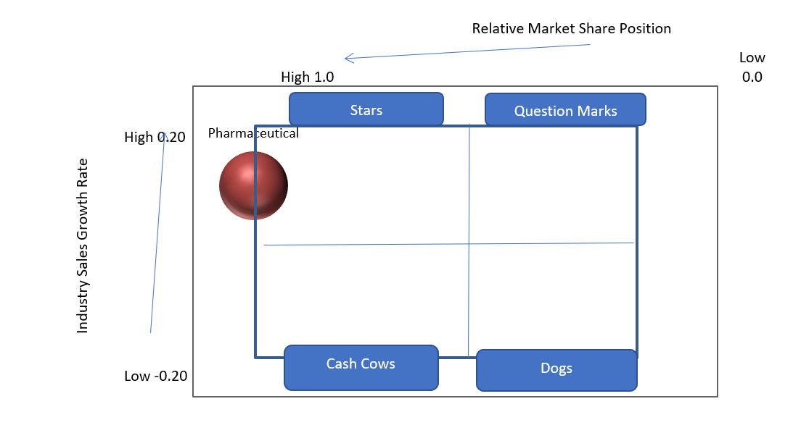
Part 3: IE Matrix

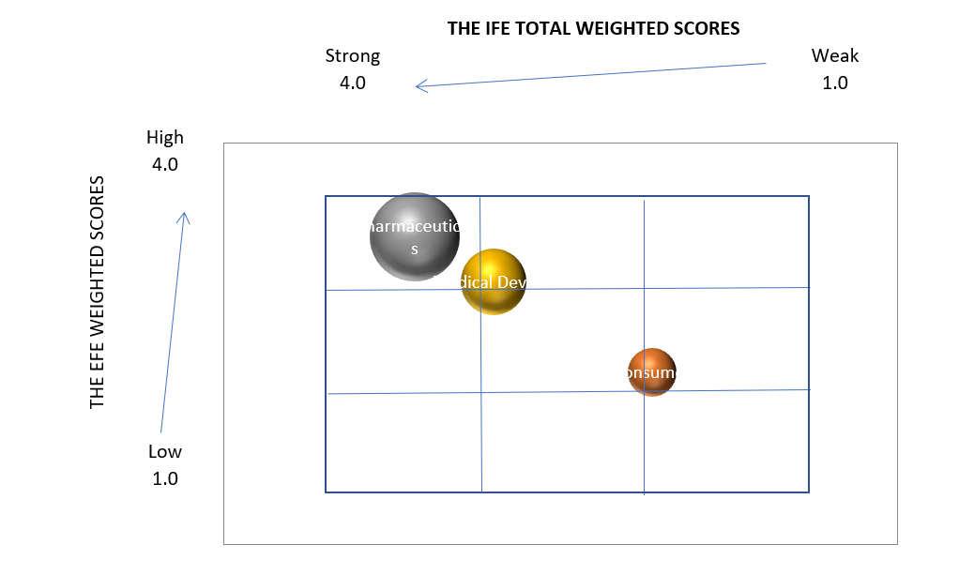
References
Dwyer, K. (2018, June 29). 6 critical risks facing the pharmaceutical industry. Risk & Insurance.https://riskandinsurance.com/6-critical-risks-facing-pharmaceuticals/
Grand View Research. (2021). Market analysis report. www.grandviewresearch.com/industry-analysis/pharmaceutical-manufacturing-market#
Johnson & Johnson. (2021). About Johnson & Johnson. www.jnj.com/about-jnj
Johnson & Johnson. (2021). 2021 Quarter 1 Report. 8ce934ea-ab5c-4ba0-9ca7-16ce975a7bc6 (gcs-web.com)
Johnson & Johnson SWOT analysis. (2021). Johnson & Johnson SWOT analysis, 1-7. http://web.a.ebscohost.com.lopes.idm.oclc.org/bsi/pdfviewer/pdfviewer?vid=5&sid=ac70f97f-3b99-47e7-9cb9-dc5f91ba14c1%40sessionmgr4006
Lehot, L. (2020). How to effectively expand your business globally. https://lopes.idm.oclc.org/login?url=https://search.ebscohost.com/login.aspx?direct=true&db=edsggo&AN=edsgcl.637945268&site=eds-live&scope=site&custid=s8333196&groupid=main&profile=eds1
Merck (2021, February 4). Merck announces fourth-quarter and full-year 2020 financial results. https://www.merck.com/news/merck-announces-fourth-quarter-and-full-year-2020-financial-results/
Mishra, M & Maddipatla, M. (2019, July 19). J&J warns of hit from generic drugs in third quarter, shares fall. Reuters. https://www.reuters.com/article/us-johnson-johnson-results/jj-warns-of-hit-from-generic-drugs-in-third-quarter-shares-fall-idUSKCN1UB14W
Pharma. (2021). Advocacy research & development. https://www.phrma.org/en/Advocacy/Research-Development

Research and Markets. (2019, September 19). Global medical devices market report 2019-2022 – A $521+ billion opportunity analysis. Intrado. www.globenewswire.com/news-release/2019/09/19/1918062/0/en/Global-Medical-Devices-Market-Report-2019-2022-A-521-Billion-Opportunity-Analysis.html#:
Team Linchpin. (2021, March 18). Trends transforming the medical device industry outlook in 2021. Linchpin. https://linchpinseo.com/trends-medical-device-industry/

